| **Ex No: 4**  **Date: 28/08/24** | **Convolutional Neural Network (CNN) Implementation for Handwritten Digit Recognition** |
| --- | --- |

**Title:**Convolutional Neural Network (CNN) Implementation for Handwritten Digit Recognition

**Objective:**To develop and implement a Convolutional Neural Network (CNN) model to recognize handwritten digits from the MNIST dataset using Python and TensorFlow.

**Description:**Handwritten digit recognition is a classical problem in computer vision and pattern recognition. The MNIST dataset is a well-known dataset comprising 70,000 images of handwritten digits (0-9) in grayscale, with each image having a resolution of 28x28 pixels.

Convolutional Neural Networks (CNNs) are a class of deep neural networks that have proven highly effective for image classification tasks. A CNN typically consists of convolutional layers, pooling layers, and fully connected layers. The convolutional layers act as feature extractors, while the fully connected layers map these extracted features to the final output classes.

In this lab, we implement a CNN model using TensorFlow and Keras to classify images from the MNIST dataset. The model architecture includes convolutional layers followed by max-pooling layers, dropout for regularization, and dense layers for classification. The model is trained and evaluated on the MNIST dataset.

**Model Architecture:**

1. **Input Layer:** 28x28 grayscale images.
2. **Convolutional Layer 1:** 32 filters, 3x3 kernel size, ReLU activation.
3. **Max Pooling Layer 1:** 2x2 pool size.
4. **Convolutional Layer 2:** 64 filters, 3x3 kernel size, ReLU activation.
5. **Max Pooling Layer 2:** 2x2 pool size.
6. **Flatten Layer:** Flattening the 2D matrix into a 1D vector.
7. **Dense Layer 1:** 128 units, ReLU activation.
8. **Dropout Layer:** 0.5 dropout rate.
9. **Output Layer:** 10 units (corresponding to the 10 classes), softmax activation.

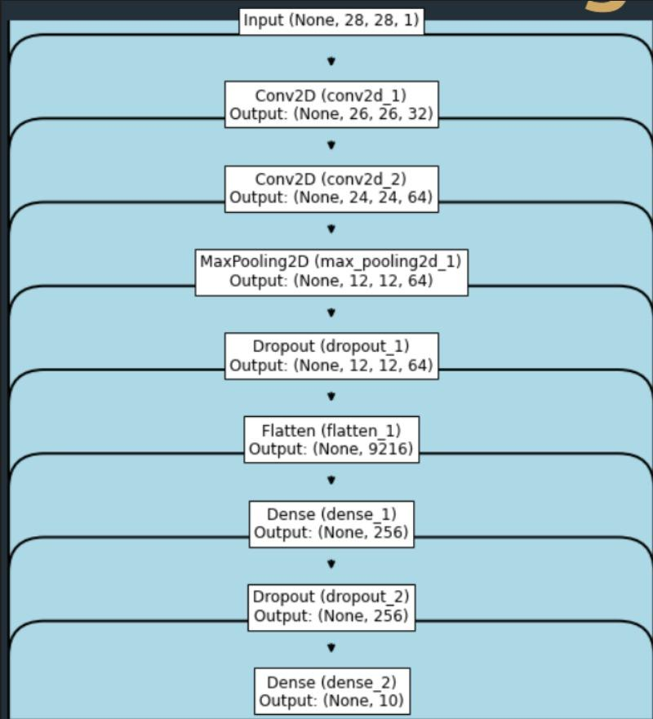

**Procedure:**

1. **Data Preparation:**
   * Import the MNIST dataset from TensorFlow/Keras.
   * Preprocess the data by normalizing pixel values to the range [0, 1].
   * Split the data into training and testing sets.
2. **Model Building:**
   * Define the CNN architecture as outlined above.
   * Compile the model with appropriate loss function (categorical_crossentropy), optimizer (Adam), and metrics (accuracy).
3. **Training:**
   * Train the model on the training data with a specified number of epochs and batch size.
   * Monitor the training process and validation accuracy.
4. **Evaluation:**
   * Evaluate the model's performance on the test set.
   * Plot the training and validation accuracy/loss curves.
5. **Prediction:**
   * Use the trained model to predict classes for new input images.
   * Display a few test images along with their predicted labels.

**Results:**

* The CNN model achieved an accuracy of [Insert Accuracy]% on the test dataset.
* Training and validation accuracy/loss curves indicate [briefly describe the model's learning behavior].

**Conclusion:**

The implementation of a CNN model for handwritten digit recognition using TensorFlow was successful. The model was able to classify digits with high accuracy, demonstrating the effectiveness of CNNs in image classification tasks. Further improvements could include experimenting with different architectures or hyperparameters to optimize performance.

**GitHub Link:**<https://github.com/Gmohith7/FundamentalsofDL.git>